Redwood Christmas Fair - Please Help!
Dear Business Owner/Manager,
We are contacting you on behalf of all the students at Redwood School. We are Rochdale’s only Secondary School that caters solely for young people with Special Needs and Disabilities. Our school is a pretty amazing place, so we would like to work together to raise additional funds for things like equipment for activities and trips out in to the community.
Every year we hold a Christmas Fair where we have craft stalls, music and food stalls. This event is our biggest fundraiser, last year we raised over £1,500 which was put towards projects that benefitted our students. The Fare will be open to parents/carers, staff and students on Wednesday 14th December 2022.
How you can help?
Donation of prizes:
We are asking for your generous support this year with a donation of a raffle prize . Prizes in the past have included meal or experience vouchers, hampers, alcohol, jewellery, electronic devices, toys and food.
Prize donors will receive recognition of their generosity in our newsletter and on our social media pages. It makes an excellent marketing opportunity for your company as we reach hundreds of people in the local communities!
Please drop off any kind donations to Redwood reception, or contact emily.murphy@redwood-school.com
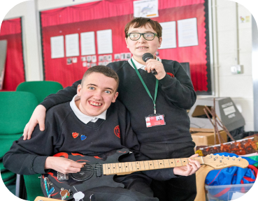
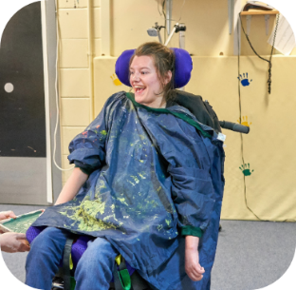
We really look forward to hearing from you – any help you can give us will make a HUGE difference. Thank you for your generous support,
Redwood Staff and Students

