.;

**Newsletter**

**Welcome to the NEWSLETTER! Every term you will receive this newsletter, filled with lots of information about the past term!**

*Parent / Carer Group*

Each half-term we have a Parent/Carer Group that family members of all students are invited to come along to. Our morning sessions take place at various places in our local community, for example, café’s & parks – where we can all have a drink together and catch up! Our alternative evenings sessions will be held at Redwood, where families can bring their children, drop them off at Youth Club whilst they attend the group. Our

hope and aim in having these sessions

is for you to meet other like-minded

people, share your own experiences,

form a supportive network and also to

find out about support services you

may not be aware of that may be able

to help you and your family in some way.

We invite various professionals, including

members of our Senior Leadership

Team, to come along to share what they do, how they can help and answer any questions you may have. The dates & times over the next academic year are here for you to pop in your diaries! Locations will be confirmed nearer the time, we do hope to see you there!

***Term Dates***

**Here is a list of important dates for next year. Please see the website for a more in depth list.**

Monday 5th September: First day back in school.

October half term: 24th October – 30th October

November 18th – Staff Training Day, School Closed

December 16th – school closes for Christmas break

January 3rd – School opens

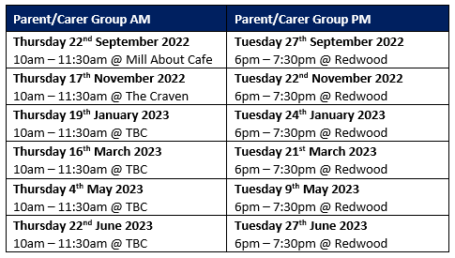

***Sports Awards***

Unfortunately, our sports awards had to be cancelled on Tuesday, due to extreme weather conditions and the lack of air conditioning in the Gracie Fields Theatre.

This event will take place in September, as we have lots of awards to give out!

***Message from the EHCP team:***

Thank you for everyone’s attendance at your child’s EHCP review, this academic year. Next year we are increasing ‘parent voice’ with the parent questionnaire, if you need any help with this or have any questions please contact **ehcp@redwood-school.com**

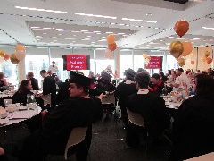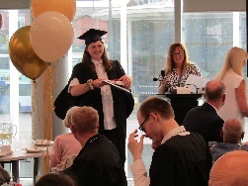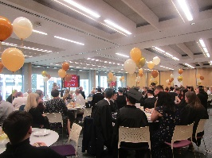

*Message from the Head:*

Following another fast paced and unpredictable year, I want to say some thankyous: Firstly, I want to thank the staff team, who have continued to work tirelessly for the good of the young people. This has been shown in the outcomes for the students and was never better illustrated than in the internship graduation last week, where we heard from the students themselves what the Redwood experience has meant to them. The atmosphere at Redwood is always something that visitors comment on, including the welcome all staff give. This included when Ofsted were in; never before have I been able to say that I have enjoyed an inspection, but the calm and confident atmosphere was great! I want to thank all parents who have supported us this year. We know as a school that without your support the young people would not experience the successes they do. We value the partnership working with you all and look forward to an exciting future together. Finally, and most importantly, I want to thank all the students. You should all be so proud of yourselves for what you have achieved this year. It is a joy being part of the Redwood community and it is the students who make it such a wonderful place to be. The variety of success means that we celebrate the diversity of our community together as you are all prepared for adult life. Next year I will be reinstating the Head’s blog to try and keep you all up to date with any developments or events at school, so please look out for it, on the website and social media.

Have a great summer everyone!

***Internship Graduation***

We all had a fabulous time at Riverside, last Friday evening celebrating our interns successes! We had our 2020- 21 interns and our 21 – 22 interns all together, and we all had a great time!

***Redwood Clubs***

Redwood is committed to offering a wide range of extra-curricular and social opportunities for students and other young people with additional needs and/or disabilities to attend.

Redwood students are able to attend Breakfast Club each morning and a selection of After School Clubs on Monday’s, Wednesday’s & Thursday’s at a small cost.

We also have a Youth Club that runs on a Tuesday evening and Saturday morning which is open to all student

If you would like your child to attend a Breakfast, After School or Youth Club – please look out for a school comms from us with links to the request forms.

For more information please look on our website or contact our Extended Schools Coordinator, Justin, via email clubs@redwood-school.com