
Connection Communication Independence Aspiration

Transition Policy

Transition Policy
At Redwood we recognise the importance of ensuring smooth transitions for learners joining our school, moving classes within our school and moving onto alternative provision/out of area/further education pathways, employment and adult social care provision. We understand the importance of ensuring transition procedures are flexible and meet the unique and individual needs of learners and their families. Redwood will make every attempt to ensure that parents are involved at every stage of their child’s transition to the school and future transitions.
Areas of Transition at Redwood:
- KS2 to KS3 Year 6-7- Primary transition to Redwood Secondary School
- KS4 to Post-16 Transition- Year 11-12 within Redwood provision to Sixth Form provision
- KS5- Transition from Redwood to Post 19 Further Education, Employment and/or Adult Social Care
- In year transfer out of Redwood School to alternative provision settings when needs can no longer be met
- In year transfer into Redwood School

KS2 to KS3 Primary transition to Redwood Secondary School setting
Transition at Redwood commences at the start of the academic year and continues throughout the calendar year. There are a range of opportunities over the course of the year to support a smooth transition for parents and the learners; these are explained in more detail below.
Redwood Tours
Throughout the year, there are scheduled opportunities for prospective parents to visit Redwood to look around, speak to staff and experience the learning environment Redwood has to offer. Parents do not have to have secured a place at Redwood to join a tour. Tours are open to any parent who has a child with an EHCP.

Redwood Parent Information Meeting
When appropriate the Redwood Transition Team visit the primary special schools and hold a meeting to introduce themselves, provide provision information, talk through the transition plan and answer any questions parents may have.

Redwood Shape Days
Opportunities for learners to experience a day in the life of a Redwood learner. Additional opportunities and sessions are offered to those who may need additional transition time based on their individual needs. SHAPE days are part of our calendar at Redwood where all learners take part in lessons, events and activities planned around learner’s health, achievement and wellbeing. There are seven SHAPE days throughout the academic year.

Redwood Parents Coffee Morning
Coffee mornings are an opportunity for parents to visit the school and meet other parents/staff and learners from Redwood in an informal social setting. These mornings take place throughout the Spring and Summer term and parents are welcome to attend as many of the mornings as they like.

TRANSITION CALENDAR
AUTUMN TERM
Date | Event | Purpose
September | Year 6 consultation with specialist primary schools (Newlands and Springside) | To gain insight into learner needs and abilities
Autumn | REDWOOD TOURS (individual tours on request) | Small group non-prejudicial visit – opportunity to see school in action
December | Observations and Engagement Sessions  Staff from Redwood visit Newlands and Springside | Information gathering, observation and engagement with learners and staff.

SPRING TERM 2025
Date | Event | Purpose
February | SHAPE Day 1  Learner visit to Redwood with staff support | Take part in community day with learners and staff at Redwood
March | SHAPE Day 2  Learner visit to Redwood with staff support | Take part in community day with learners and staff at Redwood
March | Information Sharing | Redwood staff to visit Newlands/Springside/ Mainstream to meet with key KS2 staff to share learner information
March / April | Parents Evening | Information sharing, opportunity to meet Redwood Staff and learn about Redwood
April | SHAPE Day 3  Learner visit to Redwood with staff support | Take part in community day with learners and staff at Redwood

SUMMER TERM
Date | Event | Purpose
May | SHAPE Day 4 & 5  Learner visits to Redwood with staff support | Take part in community day with learners and staff at Redwood
May | Parent Coffee Morning | Opportunity to meet key staff and current year 7 learners
May | Information Sharing | Redwood staff to visit Newlands/Springside/ Mainstream to complete transition policy to practice documentation
June | SHAPE Day 6 & 7  Learenr visit to Redwood with staff support | Take part in community day with learners and staff at Redwood
July | Year 6 TRANSITION DAY (if appropriate for individual learners)  OR  Bespoke transition visits during the last three weeks of the half term. | Transition day or more bespoke transition visits dependent on individual needs
July | Parents Evening | Preparation event for parents regarding learner starting at Redwood in September 2025

KS2 to KS3
As part of the transition process Provision Leaders will begin to establish which provision they feel will meet the young persons needs. Provision leaders will refer to the young person’s EHCP, conversations following visits to primary schools and also assessments from the SHAPE day visits.
Learners will be assigned to a class within a provision. As staff do get to know the learners this may change.
Within Redwood there are 6 provisions:
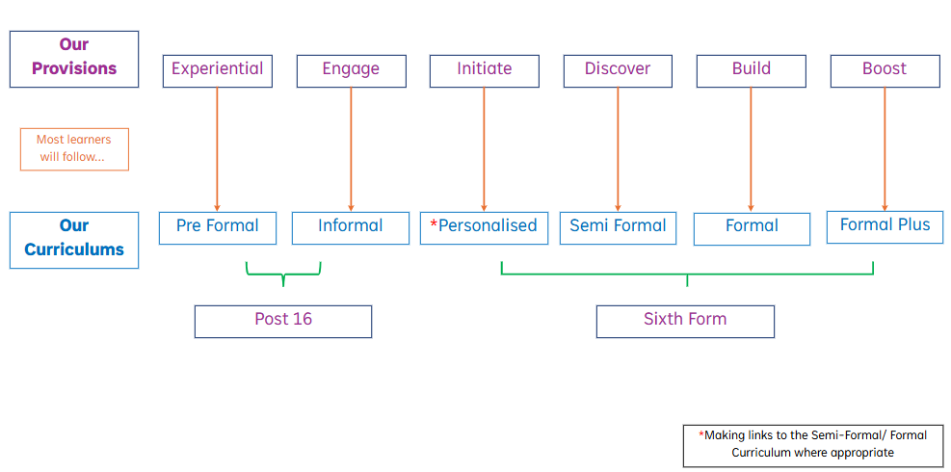
KS4 to Post-16
Learners in KS4 receive internal and external careers information advice and guidance through consultations and ‘open’ sessions with Positive Steps Advisor. Time is also spent in Pastoral groups and the year 11 EHCP annual review meeting to discuss preferred options. In October each year we hold a Redwood Futures Fair which is an opportunity for learners to explore the wide range of post-Redwood options available to them.
KS4 - 5 TRANSITION CALENDAR
Date | Event | Purpose
Autumn / Spring / Summer | Meeting between the Redwood and LA – Transition arrangements for Year 11 learners | Initial indication of Post 16 destinations identified, places applied for and places confirmed.
Autumn / Spring / Summer | REDWOOD TOURS (individual tours on request) | Small group non-prejudicial visit – opportunity to see school in action
October | Parents/Carers Futures Fair | Opportunity to meet all future destination providers
Dec, Jan, Feb March | Post 16 visits | Transition visits
May | Post 16 groups clarified | Planning for September can be facilitated
June | Transition Coffee Morning | Opportunity for learners, parents and carers to meet together, gain information and prepare for September
May, June, July | Bespoke Transition Visits dependent on individual need | Robust transition to post 16

Post 16 Transition beyond Redwood
Half-termly planning meetings take place with the local authority to ensure appropriate and well-planned destination success.
The well-established transition programme at Post 16 ensures that all learners, parents and carers are aware of future provision within the local offer be that further education, employment or access to adult social care provision.
Learners on the Internship programme have worked through a package that provides education, employment, enrichment, independence and social opportunities for the Interns. This enables them to make the transition into adulthood by being work and life ready. The Internship Manager will transition Interns into either secured employment, voluntary employment, college or a combination of those three elements. Interns are supported throughout this process by school staff and Positive Steps.
Post 16 learners also receive internal and external careers information advice and guidance through consultations and ‘open’ sessions with school staff and Positive Steps Advisor.
Learner’s future provision is identified at EHCP annual review meetings. The careers and futures advisor lead in school is involved in this process and arranges visits, interviews and taster days for learners wanting to go on to further education and supports them through the application process. The transition team from adult social care become involved with and attend the EHCP annual reviews of learners with more complex needs in year 13 and 14 as they are coming up to 18 years. Redwood works closely with the adult transition team to find suitable providers, share information, and set up and facilitate visits.
In year transfer to an alternative educational setting
For Learners whom Redwood is no longer able to meet their needs, we work with outside agencies and providers to share information and find the best provision for them to be successful and safe. At KS4, if appropriate some learners leave Redwood at Year 11 and go onto further education. Again, the Positive Steps Advisor is involved in this process to arrange visits, interviews and taster days for these learners and supports them through the application process.
In year transfer into Redwood
Any parent/ carer wishing to enquire about an admission should in the first instance contact the SEN Team at the Local Authority 01706 925140. Local Authority feel that Redwood would be correct place they consult with Redwood to see if there are places available and if needs can be met.

If you have any questions or would like to discuss any of the elements of this policy in more detail with a member of senior staff at Redwood, please contact the school on 01706 750815.

Reviewing this Policy
This policy will be regularly reviewed by the governing body and updated annually in line with Redwood School’s policy schedule.
Reviewed: September 2025
Due to review: September 2026
By: Rosie Thorley (Deputy Headteacher)

